**EXP NO 17**

Install Virtual box/VMware Workstation with different flavors of Linux or windows OS on top of your present windows environment.

**PROCEDURE**

**Step-1:**

Open VMware and select “Create a new virtual Machine”

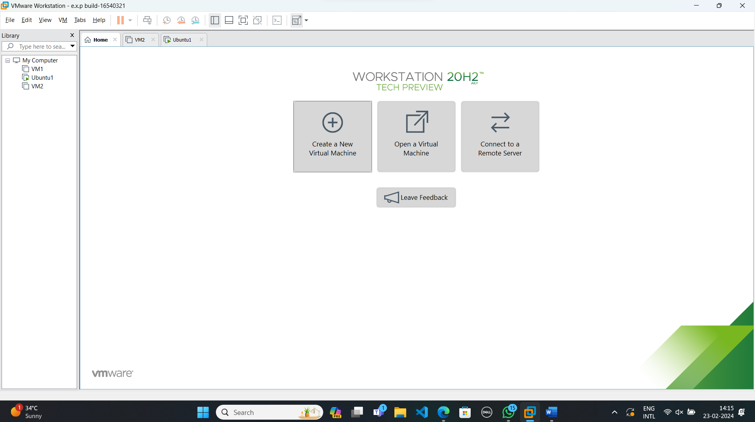

**Step-2:**

Do the basic configuration settings.

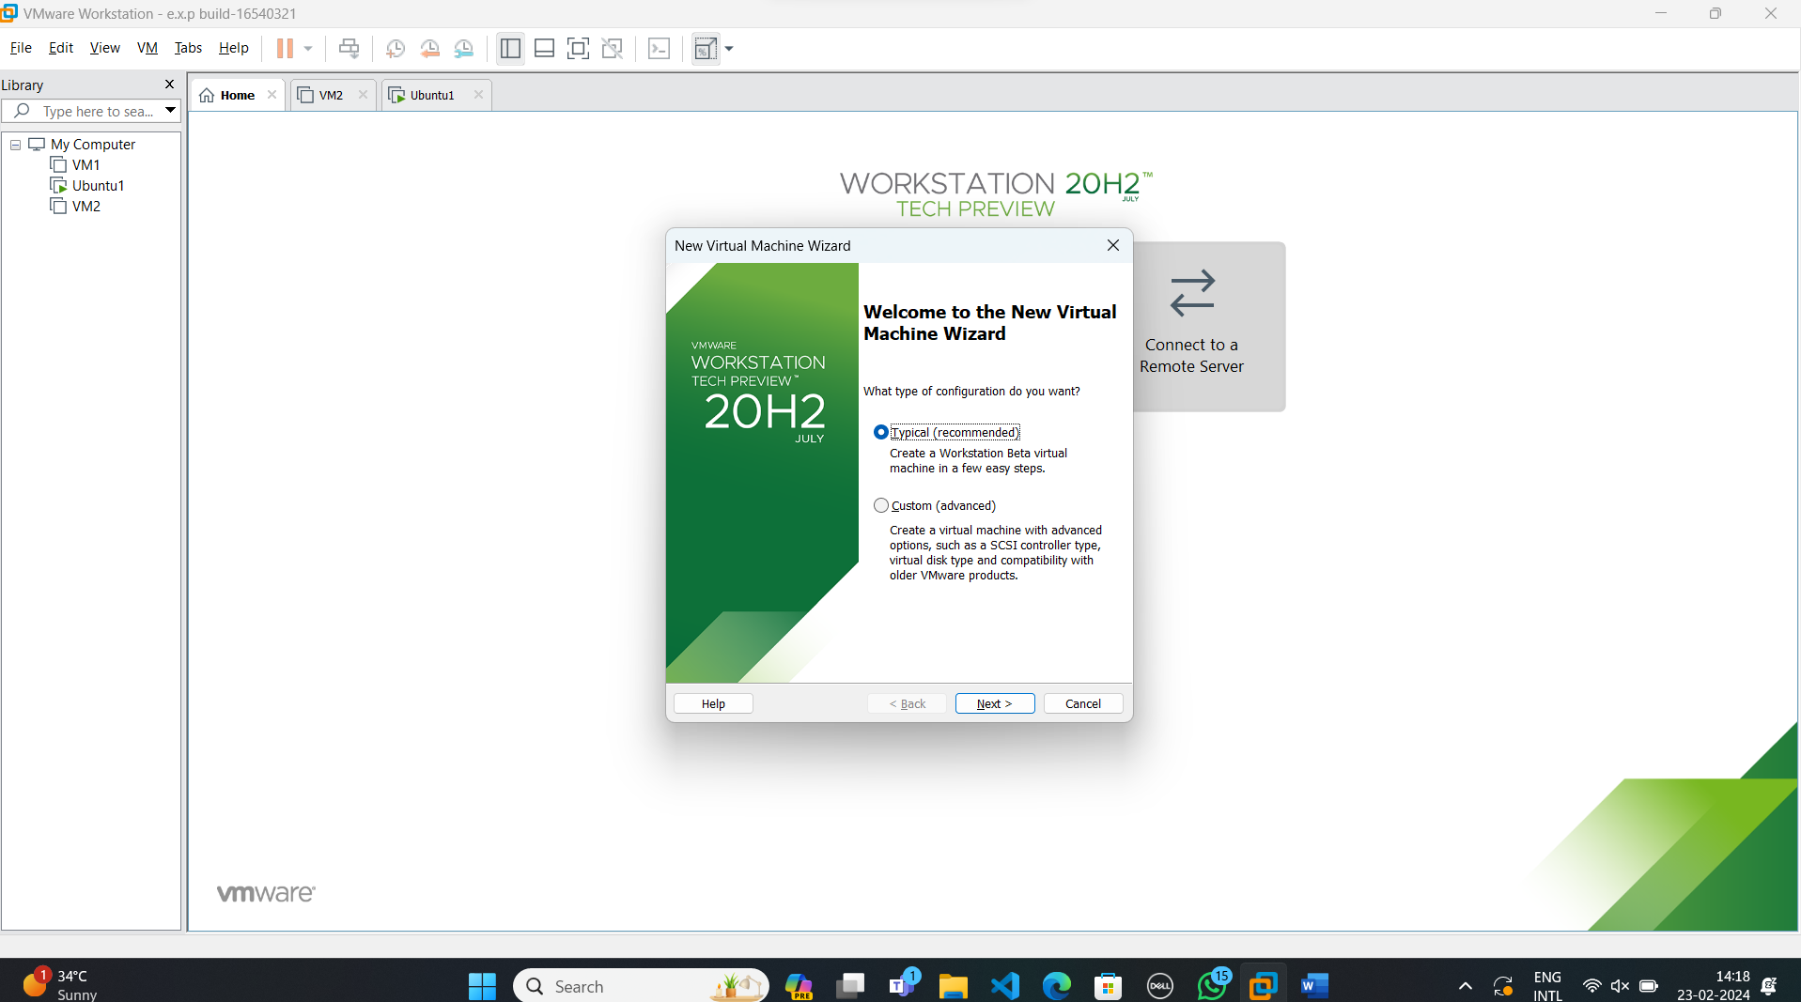

**Step-3:**

Select disk image file option and load the OS file.

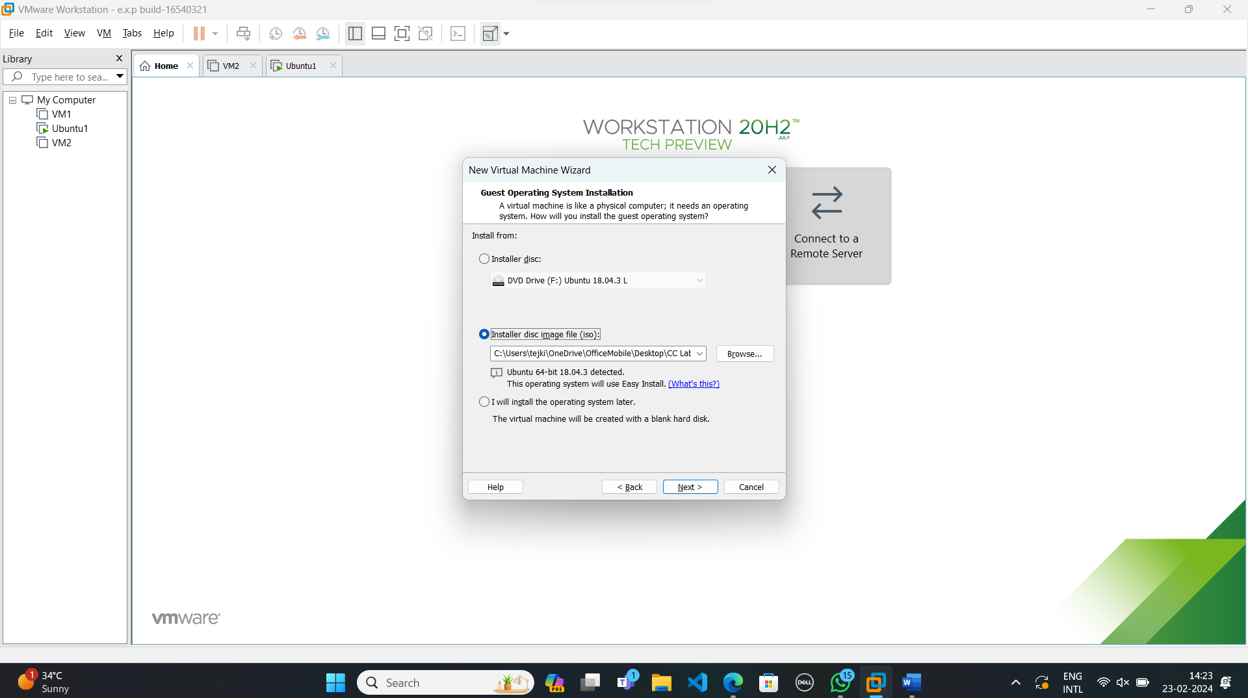

**Step-4:**

Create new user name and password.

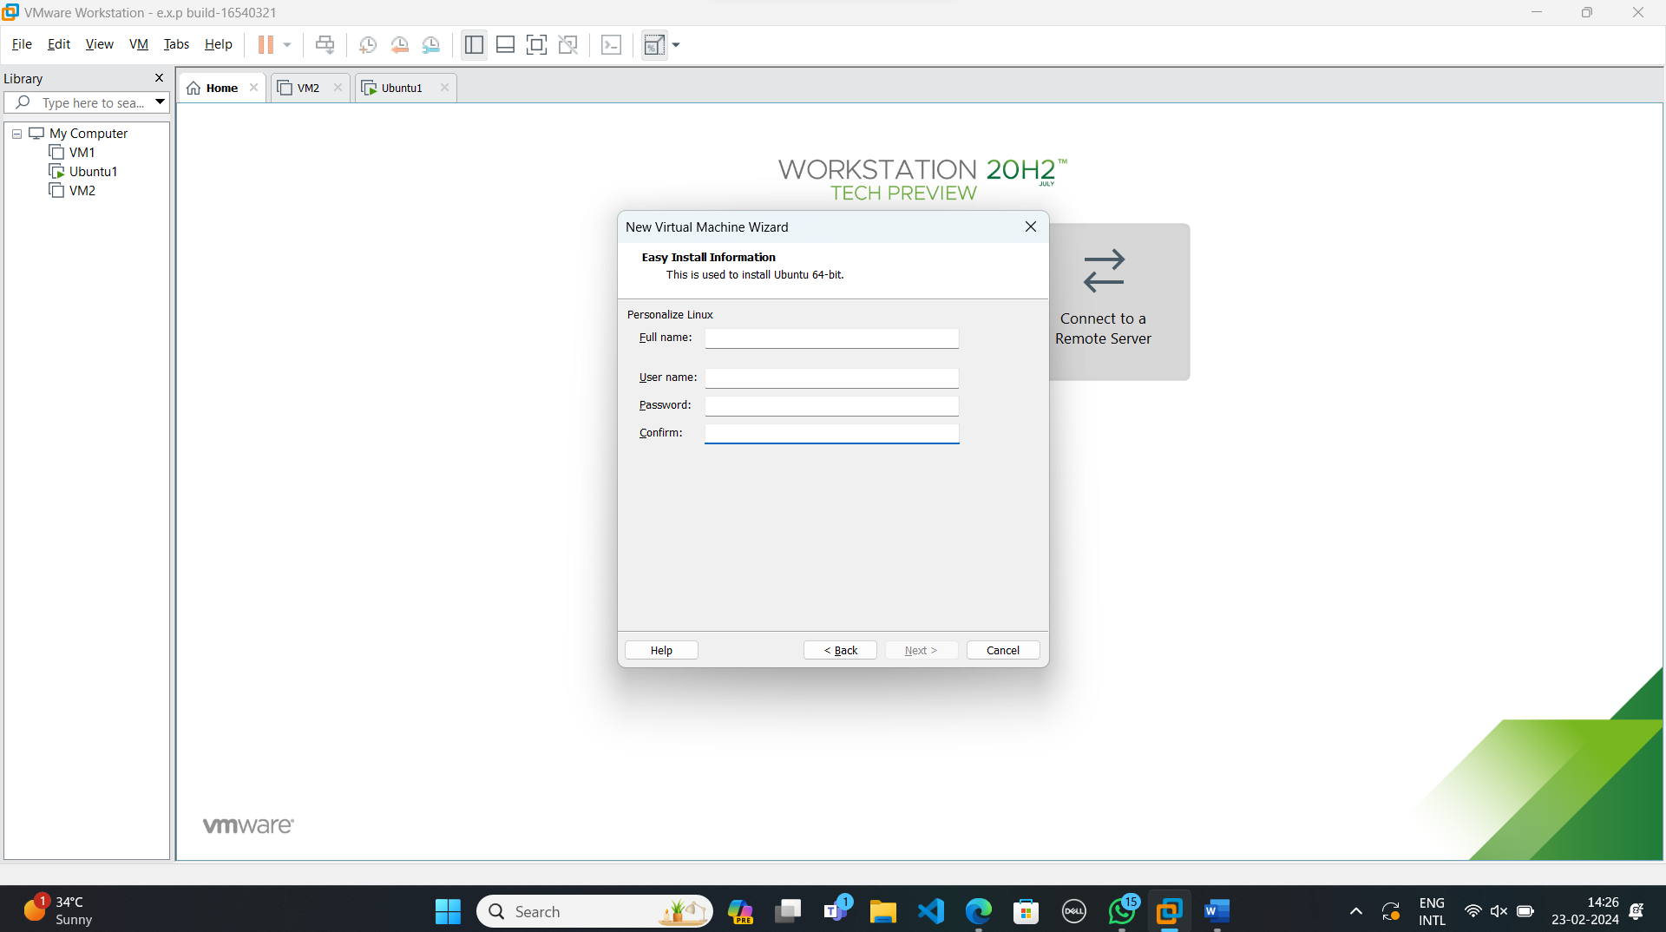

**Step-5:**

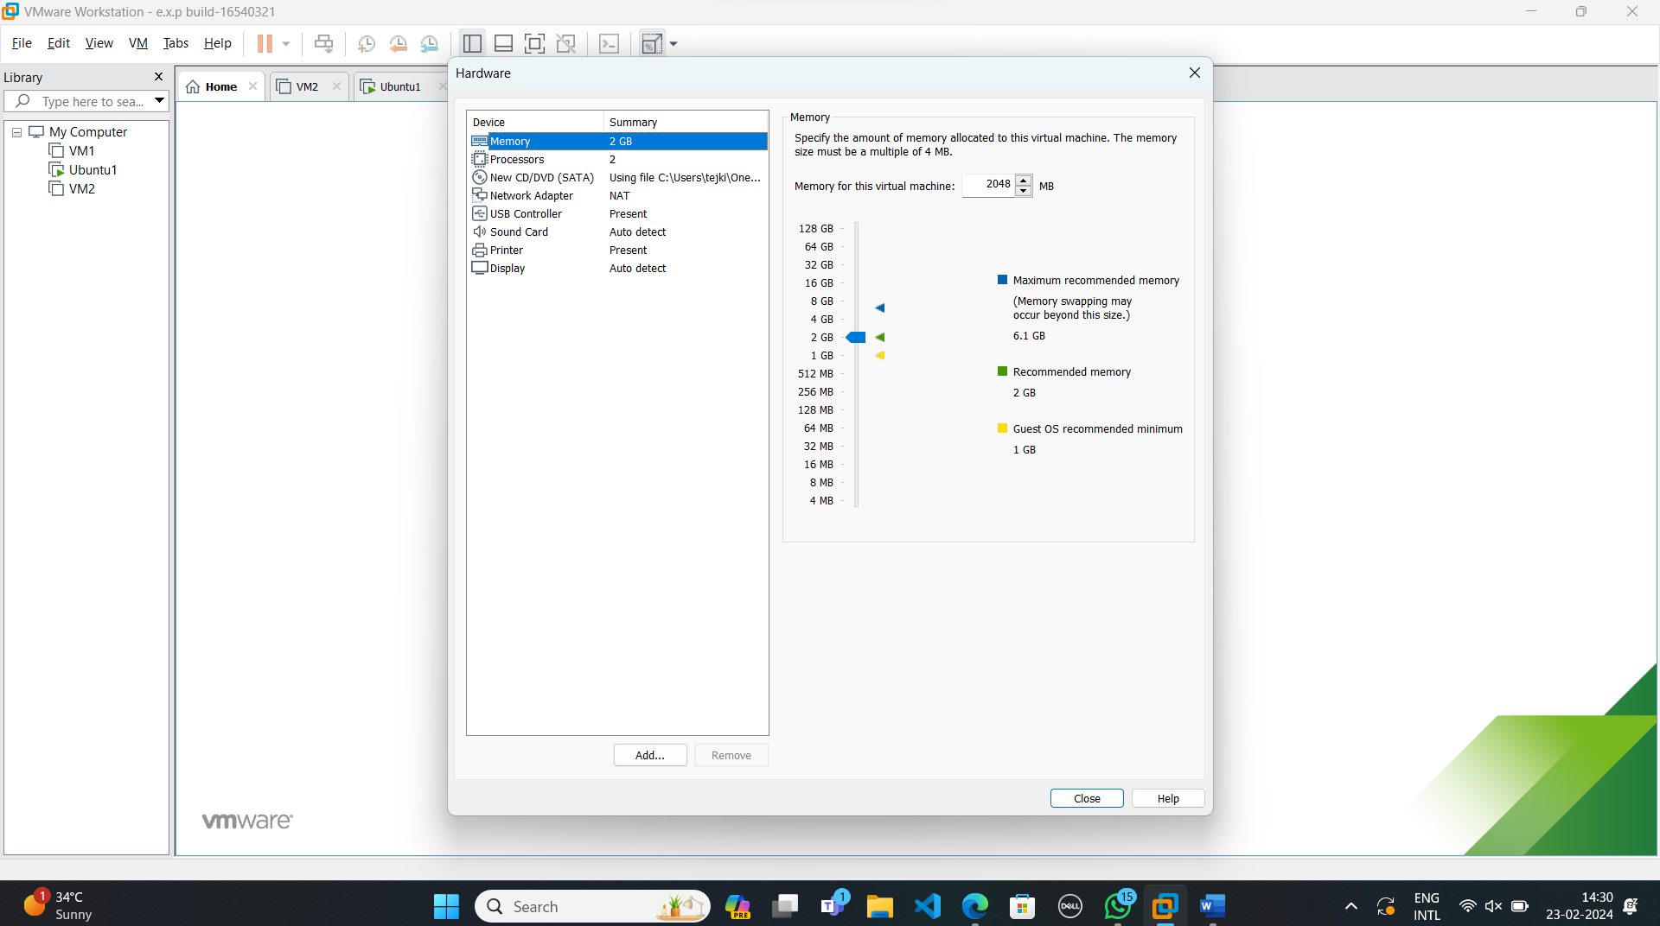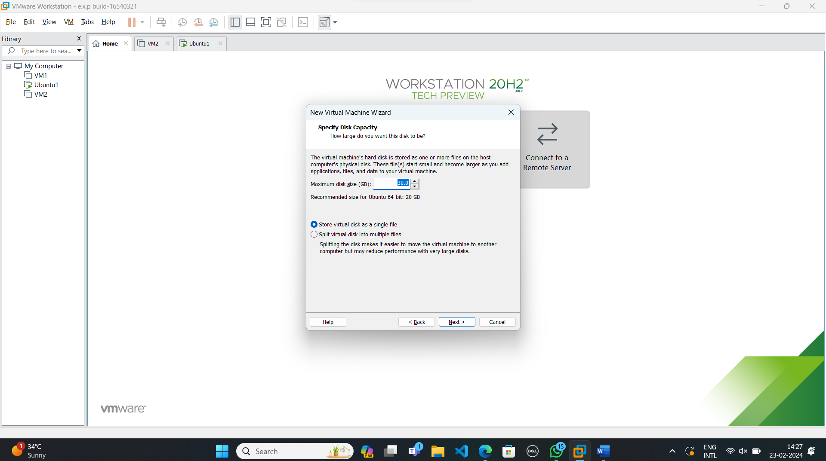

**Step-6:**

Launch the Virtual Machine.

